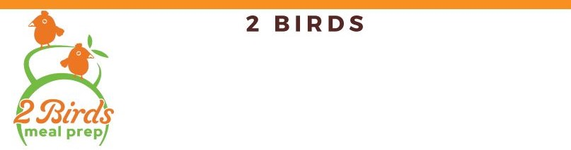

MACROS

MENU ITEMS | CALORIES | FAT | CARBS | PROTEIN
- Spicy Tuna Wrap (side included in macros) | 331 | 10 | 38 | 21
- Buffalo Wrap (chicken, side included) | 340 | 11 | 29 | 26
- Buffalo Wrap (cauliflower, side included) | 359 | 18 | 32 | 7
- Teriyaki Chicken Lettuce Wraps | 206 | 4 | 14 | 26
- Teriyaki Tofu Lettuce Wraps | 106 | 7 | 12 | 12
- Big Gains Meatloaf (sides included) | 330 | 13 | 27 | 27
- Hawaiian Chicken Bowl | 348 | 4 | 52 | 28
- Veggie-Stuffed Summer Rolls | 377 | 12 | 50 | 9
- Chicken Fajitas Bowl | 292 | 3 | 35 | 30
- Shrimp Fajitas Bowl | 268 | 1 | 35 | 32
- Steak Fajitas Bowl | 342 | 9 | 35 | 30
- Cashew Stir Fry | 554 | 24 | 86 | 16
- Mango Curry | 396 | 28 | 37 | 13
- Classic Lasagna Rolls (macros per 1 roll serving) | 233 | 10 | 18 | 18
- Vegan Lasagna (macros per 1 serving) 8 Svg | 320 | 13 | 43 | 18
- T Rex Casserole (macros per 1 serving) 8 svg | 296 | 3 | 54 | 15
- T REX add 15oz chicken | 384 | 5 | 54 | 31
- Chicken Enchiladas (macros per 1 serving) 8 svg | 295 | 12 | 18 | 28
- Vegan Enchiladas (macros per 1 serving) | 324 | 6 | 58 | 17
- Mexican Street Corn Soup 10 svg (macros per 1) | 277 | 11 | 38 | 7
- Pork Lo Mein | 255 | 7 | 18 | 22
- Veggie Lo Mein | 260 | 7 | 18 | 14
- Chicken Lo Mein | 311 | 5 | 25 | 34
- 2 Birds House Salad (per 1 serving) 6 svg | 29 | 1 | 3 | 2
- 2 Birds House Salad Dressing (per 1 serving) | 110 | 6 | 3 | 0
- 2 Birds Balsamic Dressing (per 1 serving) | 90 | 5 | 4 | 1
- Family-size Rice and Beans 8 svg | 314 | 1 | 62 | 14
- Family-size Jasmine Rice 8 svg | 80 | 0 | 18 | 2
- Bodybuilder Chicken (6oz) | 280 | 6 | 0 | 53
- Bodybuilder Steak (6oz) | 270 | 14 | 0 | 36
- Bodybuilder Shrimp (6oz) | 135 | 1 | 0 | 33
- Bodybuilder Tofu (6oz) | 129 | 8 | 3 | 14
- Bodybuilder Parmesan Asparagus | 78 | 4 | 8 | 5
- Bodybuilder Bacon-Roasted Brussels Sprouts | 136 | 12 | 2 | 7
- Bodybuilder Air-Fried Sweet Potatoes | 115 | 2 | 22 | 2
- Bodybuilder Green Beans | 49 | 2 | 8 | 2
- Bodybuilder Quinoa | 111 | 2 | 20 | 4
- Bodybuilder Brown Rice | 124 | 1 | 26 | 3
- Bodybuilder Jasmine Rice | 80 | 0 | 18 | 2
- Bodybuilder Zucchini Noodles | 25 | 0 | 6 | 1
- Bodybuilder Cauliflower Rice | 31 | 2 | 3 | 1

